RISK ASSESSMENT AND STANDARD OPERATING PROCEDURE

1. PERSON CARRYING OUT ASSESSMENT
Name | Nanet Willumsen |  | Position |  |  | Research Technician |  |  | Date |  | 06/09/2020
2. DESCRIPTION OF ACTIVITY (include storage, transport and disposal if relevant)
Conjugation of metal tags to antibodies, for imaging mass cytometry (IMC)
Protocol:
For complete guide see: https://www.fluidigm.com/binaries/content/documents/fluidigm/resources/maxpar-antibody-labeling-user-guide-prd002rev14/maxpar-antibody-labeling-user-guide-prd002rev14/fluidigm%3Afile
In brief:
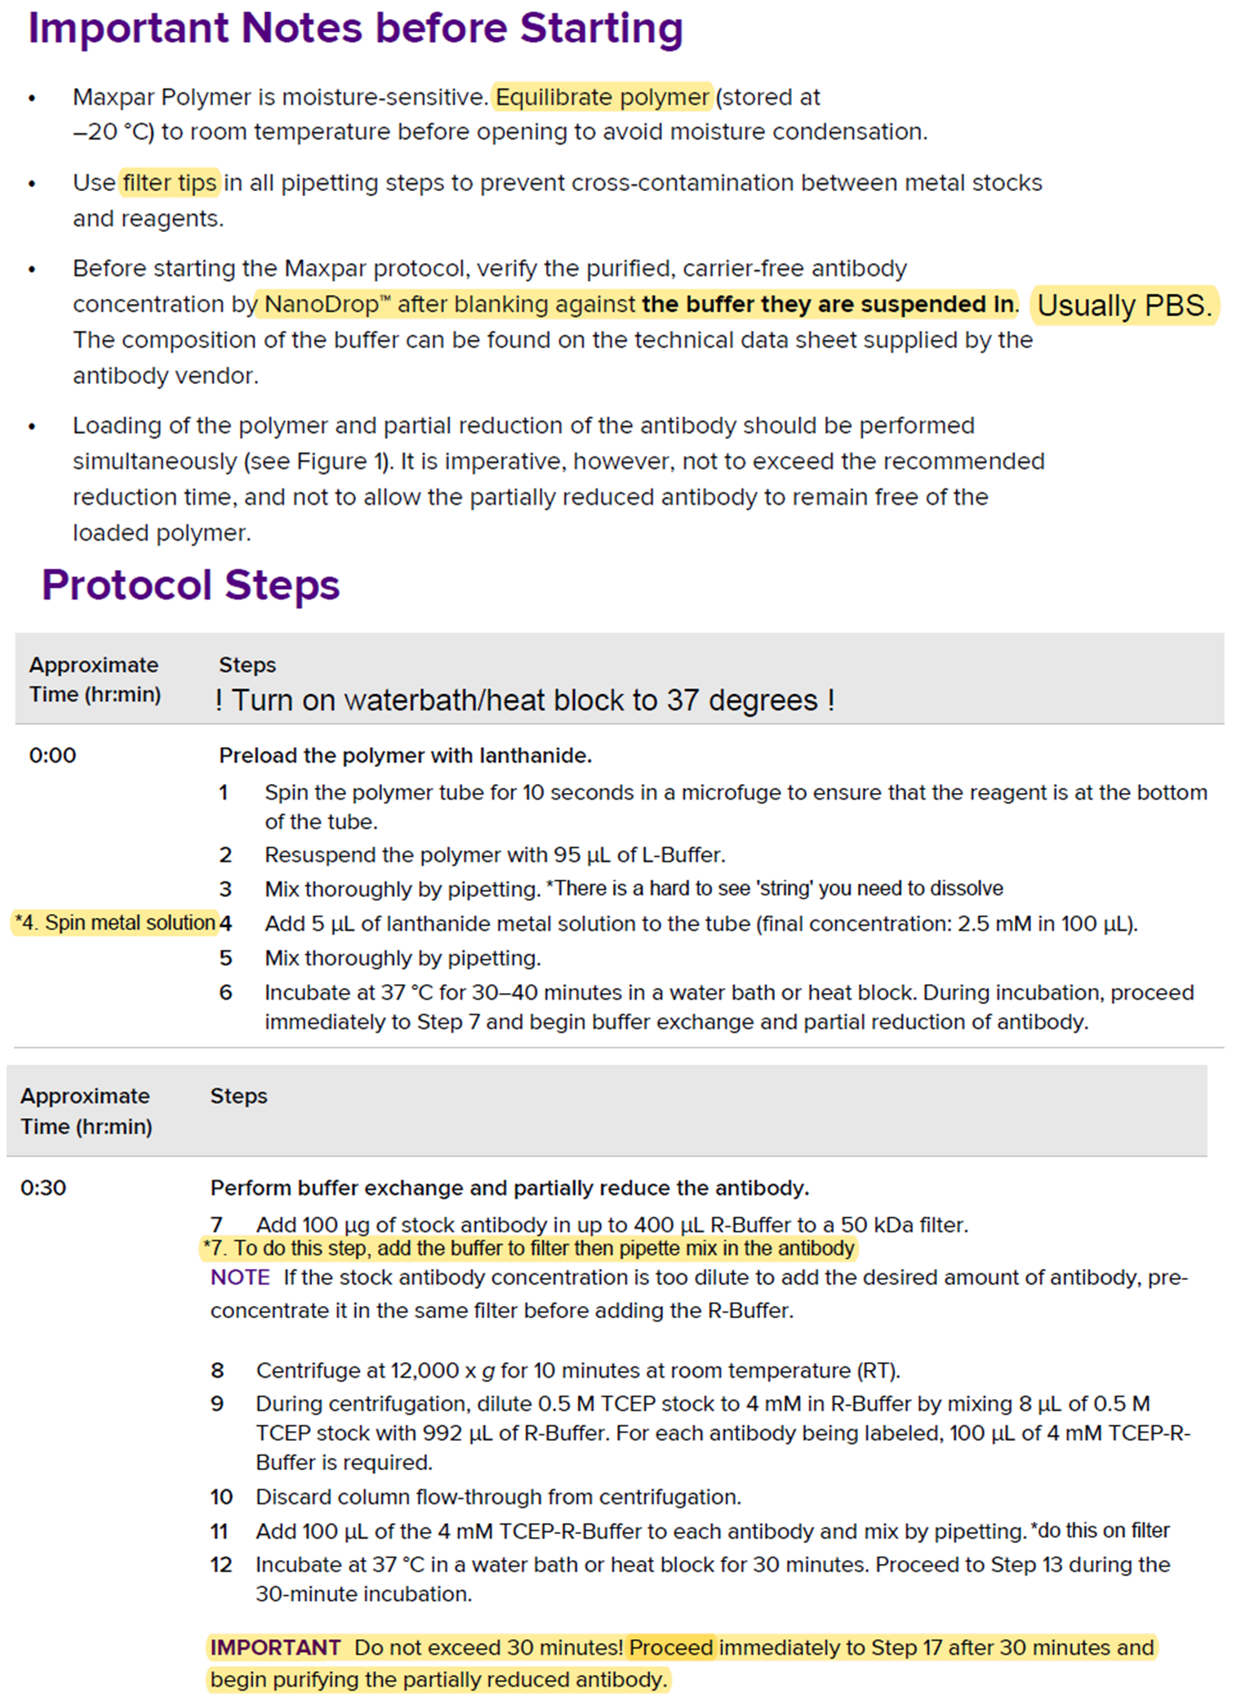

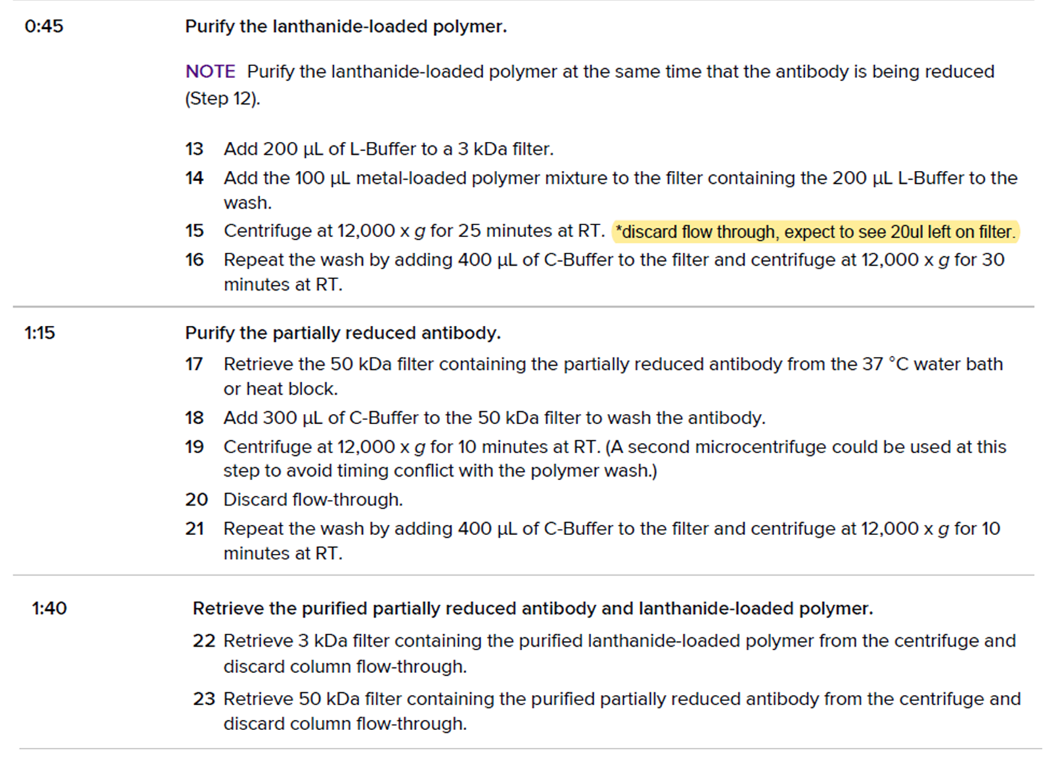
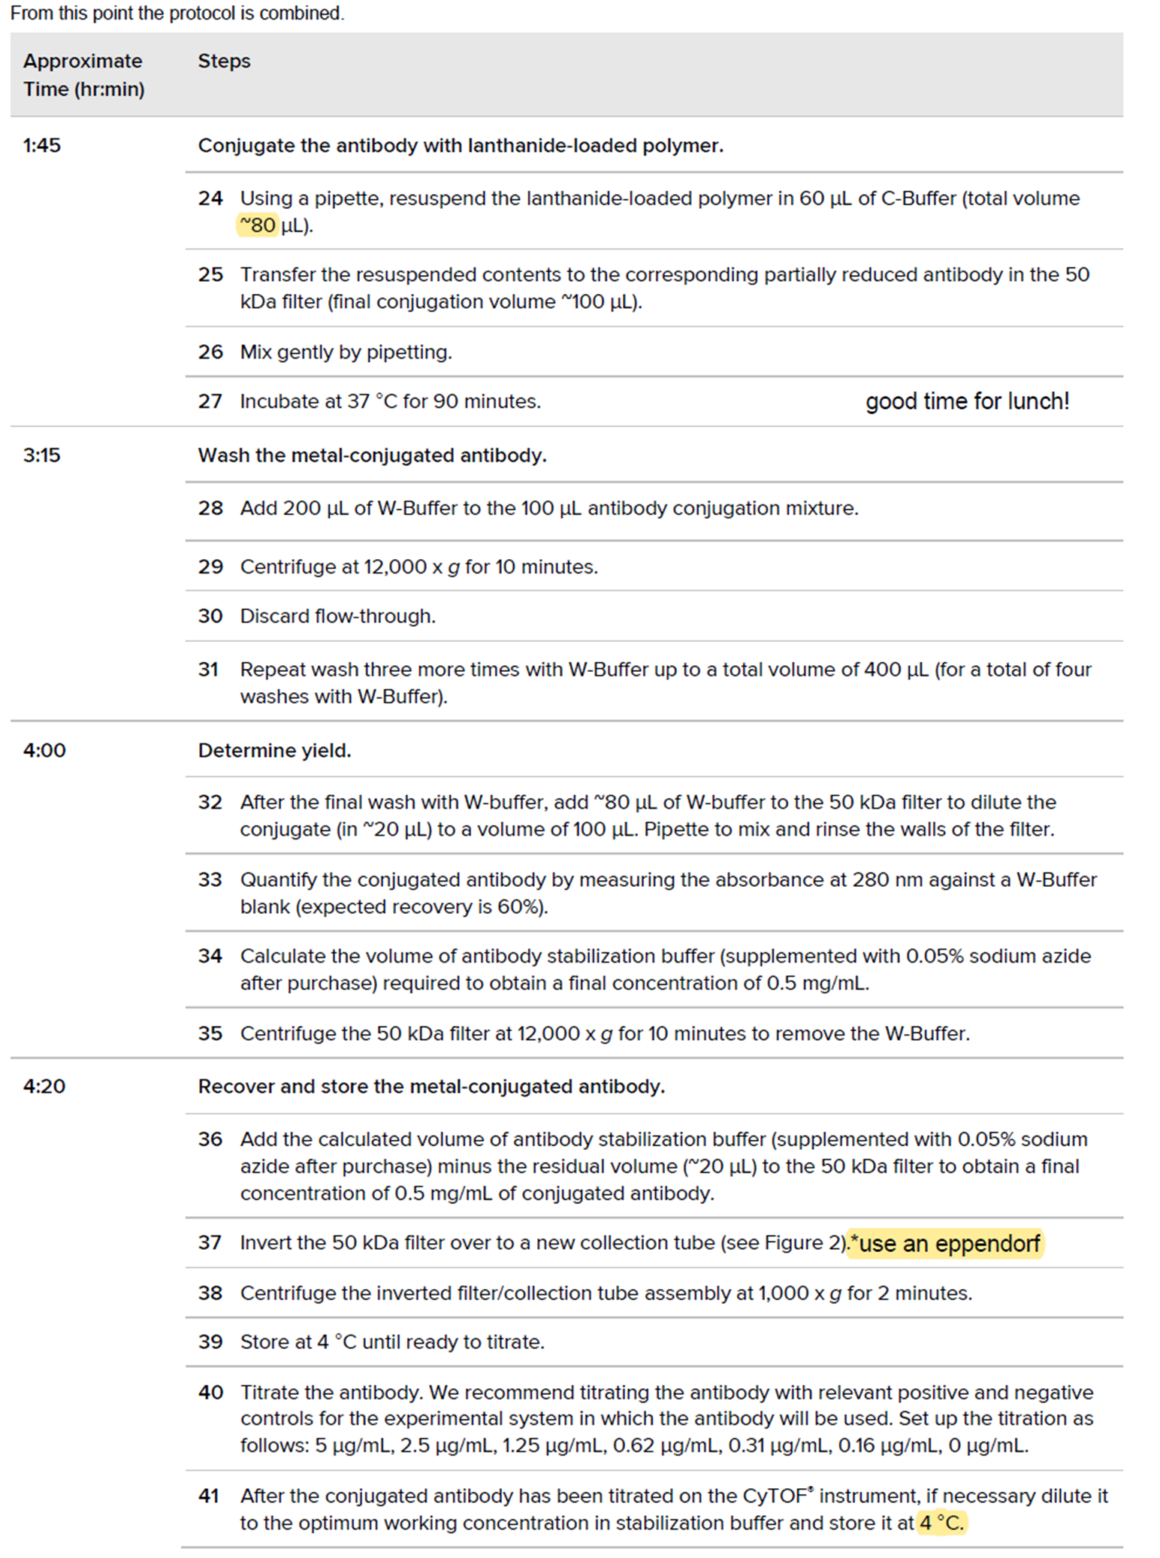

3. LOCATION
Campus | Hammersmith |  | Building |  |  | Burlington Danes |  |  | Room |  | 4th floor labs
4. HAZARD SUMMARY
Accessibility |  | X |  |  |  |  | Mechanical |  |  |  | X
Manual Handling |  | X |  |  |  |  | Hazardous Substances |  |  |  | Y
Electrical |  | X |  |  |  |  | Noise |  |  |  | X
Working at height |  | X |  |  |  |  | Extreme temperature |  |  |  | X
Falling objects |  | X |  |  |  |  | Pressure/steam |  |  |  | X
Trip hazards |  | X |  |  |  |  | Other |  |  |  | X
Lone Working Permitted? |  | Yes No |  |  |  |  | Permit-to-Work required for planned maintenance? |  |  |  | Yes No N/A
5. Who might be harmed and how?
Staff / students |  |  |  |  |  |  | Cleaners, engineers etc
Support staff |  |  |  |  |  |  | Other
6. How often is the process being carried out?
Once a day Once a week Once a month Every 6 months Annually
Other – give details Initially procedure will be conducted frequentLY, after which the procedure will only be used rarely
7. Brief description of the procedure |  |  |  |  |  |  | Precautions (Controls) in place |  |  |  |  |  | Is risk high, medium or low?
Using TCEP |  |  |  |  |  |  | H314 - Causes severe skin burns and eye damage  Use PPE. Only small volumes used at a time – 8µl diluted in 992µl buffer. |  |  |  |  |  | Low
8. Are extra precautions needed? If no please tick box and move onto next section
If yes, please describe |  |  |  | Who has been asked to do this? |  |  |  |  |  | By what date?
9. EMERGENCY ACTIONS
First Aid treatment for skin contact with TCEP: P303 + P361 + P353
Remove any contaminated clothing. Rinse skin well with water for a prolonged period. If necessary seek medical attention.

First Aid treatment for inhalation of TCEP: P304 + P340
Remove person to a well ventilated area. If person seems to become dizzy or loses consciousness call security and wait for emergency services to arrive.

First Aid treatment for eye splash with TCEP: P305 + P351 + P338
Rinse thoroughly for at least 15min using the eye wash station. If necessary, seek medical attention. Remove contacts if easy to do so.

First Aid treatment for ingestion: P301 + P310
Immediately seek medical attention.
Chemical Spillage
Wearing PPE, clean up with paper towel and water.

Emergency support through security: 4444 (+442075891000)

In all instances of accident OR near miss, notify the safety department and complete a SALUS report.
https://www.imperial.ac.uk/safety/safety-by-topic/accidents--incidents/

Occupational health contacts: https://www.imperial.ac.uk/occupational-health/
email: occhealth@imperial.ac.uk phone: +44 20 7594 9401

If downloaded, can use SafeZone APP to contact help: https://www.imperial.ac.uk/estates-facilities/security/safezone/
10. Monitor and review
Controls should be monitored: daily weekly monthly 6 monthly annually other
I will review this risk assessment at least every 6 months every 12 months
Immediately in the event of process / location change or incident or accident
11. Training record – use this section to record the names and date of any persons you are training in this risk assessment and associated procedures
Name |  |  |  |  | Date |  |  | Name |  |  |  | Date
https://www.imperial.ac.uk/safety/forms/ for all specific risk assessment forms.

